Matrix4x4

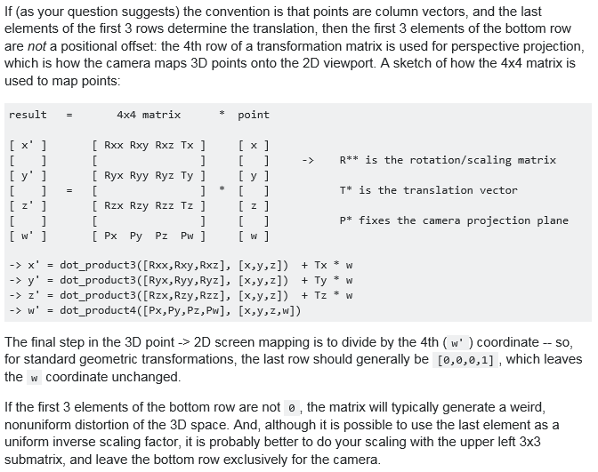

Useful links:

http://www.songho.ca/opengl/gl_matrix.html

